DEPARTMENT OF EDUCATION

DIVISION OF BOHOL

**ENGLISH GRADE X LEARNING ACTIVITY SHEET Module 4 Lesson 1.1**

*Title* : Approaching Differences: Getting to Know More and Be Proud of our Country

*Learning Targets*: Use locational skills to gather information from primary and secondary sources

of information.

Plot information gathered in an appropriate graphic organizer.

*Reference*: English 10 Learner’s Manual (Authors:)Almonte, Liza et. al. (pages:)407-408

Video clip – “It’s More Fun in the Philippines”

**Concept:**

The Philippines is laden with fantastic resources that the people have already utilized. The country is given the warm and tranquil white sand-beaches of Boracay, delicate chocolate hills in Bohol, the awesome underground river in Palawan, the genius of the Banaue Rice Terraces, and the beauty of Camiguin. Really, the list goes on and on. Apart from the natural wonders that are discovered and wonders that still need to be explored, our country is blessed with citizens who refuse to give in to despair. Only in our country will one find people who will smile amidst disasters and national calamities. Come hell or high water, the Filipinos will brave any challenge or obstacle with faith in God, a heart full of hope and love, and a soul that will always be resilient.

**Task 1. You are now going to watch a video clip. After watching the video clip, complete**

**the concept map by supplying it with the appropriate information. Write the key**

**concepts about the topic on the circles and the details about these key concepts**

**on the rectangle. It is very important to closely watch the video.**

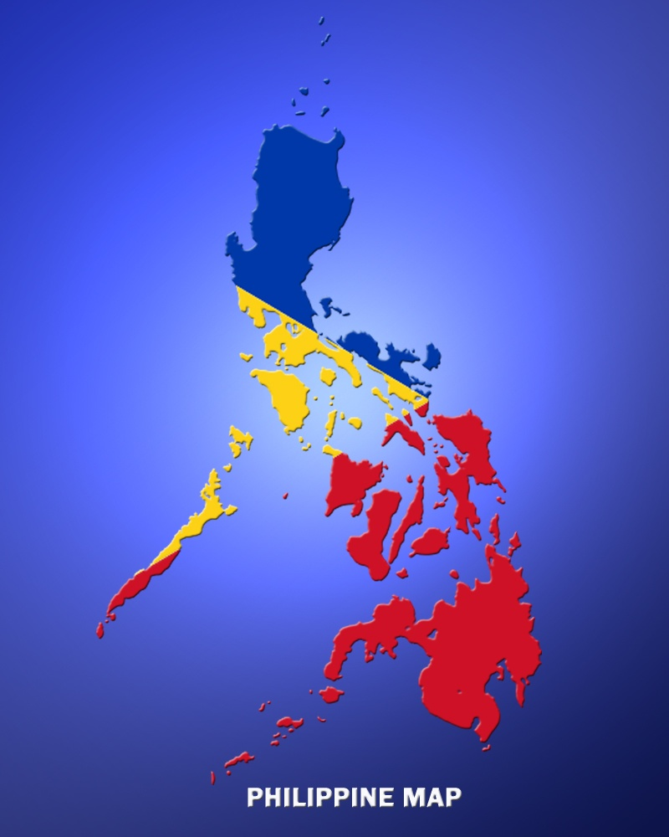

**Processing Questions:**

1. After watching the video, did you see how diverse our country really is?
2. What new information did you gather from the video?

DEPARTMENT OF EDUCATION

DIVISION OF BOHOL

**ENGLISH GRADE X LEARNING ACTIVITY SHEET Module 4 Lesson 1.2**

*Title* : Approaching Differences: Getting to Know More and Be Proud of our Country

*Learning Targets*: Use locational skills to gather information from primary and secondary sources

of information.

*Reference*: English 10 Learner’s Manual (Authors:)Almonte, Liza et. al. (pages:)409-410

**Concept:**

You may ask, how diverse is the Philippines? To give a glimpse of how diverse the country is: The Philippines is composed of 7,107 islands which make the country an archipelago. There are seven major ethnic groups that can be further divided into 183 ethnic and ethno linguistic groups who speak 176 local languages. Given these facts, it is but plausible that differences may sometimes arise among people. The challenge now is how to approach and respect each other’s differences to realize a common goal.

Sources of information are often categorized as primary or secondary depending upon their originality. A primary source provides direct or firsthand evidence about an event, object, person, or work of art. It provides the original materials on which other research is based and enable students and other researchers to get as close as possible to what actually happened during a particular event or time period. Examples are autobiographies, memoirs, diaries, interviews, surveys, newspaper articles, speeches, original documents like birth certificates, artifacts of all kinds, and patents. Secondary sources describe, discuss, interpret, comment upon, analyze, evaluate, summarize and process primary sources. Generally one or more steps removed from the event or time period and are written or produced after the fact with the benefit of hindsight. Examples are bibliographies, biographical works, reference books, literature reviews, history books, textbooks, indexes, abstracts, commentaries and treatises.

**Task 1. Classify the materials listed below whether it is a primary or a secondary source of**

**information.**

____________ 1. Letters and Diaries ______________ 6. Encyclopedia

____________ 2. History textbook ______________ 7. Newspaper

____________ 3. Government documents ______________ 8. Journals

____________ 4. Manuscripts ______________ 9. Magazine

____________ 5. Video tape ______________10. Artifact

**Task 2. Word Match. Match the words in column A with the definitions in column B. Write the letter of the correct answer on each blank.**

**A B**

_____ 1. tame a. breathe long and loud

_____ 2. neglect b. no longer wild

_____ 3. sigh c. to fail to give the proper care or attention

_____ 4. burrow d. a ceremonial act

_____ 5. rite e. necessary; important

_____ 6. essential f. a hole dug as a living space by small animals

g. a pointless star

DEPARTMENT OF EDUCATION

DIVISION OF BOHOL

**ENGLISH GRADE X LEARNING ACTIVITY SHEET Module 4 Lesson 1.3**

*Title* : Approaching Differences: The Little Prince

*Learning Targets*: Explain how the elements specific to a genre contribute to the theme of a

particular literary selection.

Express appreciation for sensory images used.

*Reference*: English 10 Learner’s Manual (Authors:) Almonte, Liza et. al. (pages:)410-415

**Concept:**

The advent of technology and the popularity of social media have proven that the gap between people in the 21st century has almost completely waned. With one search and a simple click on *facebook*, any user can add and confirm as many friends as one wants. With the convenience that technology brings in making friends, do you think that being a friend and befriending another has become superficial?

Let us now read – ***The Little Prince*** – and embark on his discovery of friendship.

**Task 1. Do Background Check – reading anticipation guide and the author’s background**

**information. Read *The Little Prince***

**Task 2. Answer these processing questions**

1. Who are the characters present in the excerpt? Describe each.
2. How important is the ‘rite’ or ‘ritual’ of taming in the friendship of the Little Prince and the Fox?
3. Do you think you have tamed another and have been tamed as well?

**Task 3. Describe the Little Prince and the Fox by writing a sentence that would appeal to the senses. Be sure to use words that will create pictures in the minds of your readers.**

**Let the graphic organizer below help you in this activity.**

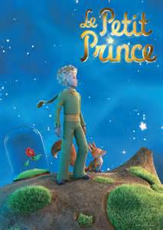

**Touch**

**Smell**

**Taste**

**Hearing**

**Sight**

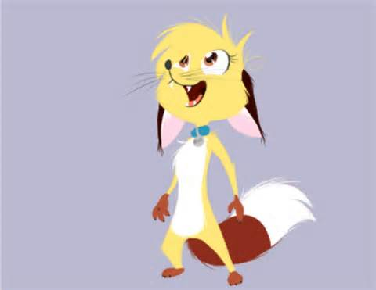

DEPARTMENT OF EDUCATION

DIVISION OF BOHOL

**ENGLISH GRADE X LEARNING ACTIVITY SHEET Module 4 Lesson 1.4**

*Title* : Selecting and Limiting a Topic for a Research Report

*Learning Targets*: Get familiar with technical terms in research

Appreciate the importance of a well prepared research report

*Reference*: English 10 Learner’s Manual (Authors:) Almonte, Liza et. al. (pages:)417-418

**Concept:**

In order to successfully complete a research report, you have to develop and limit a good research topic. You have to realize that selecting and limiting a good research topic may not be as easy as it sounds. The research topic must be focused enough to be significant and interesting, yet comprehensive enough for you to find adequate information. Here are the steps in selecting and limiting your research topic:

1. **Brainstorm for Ideas** – What local treasure or heritage in the community would you like to research about? Why does it interest you that you would like to know more about it?
2. **Identify the Sources of General Background Information** – What sources of information can you use to gather information? Would you have access to these sources?
3. **Focus on your Topic** – What specific area or factor of the local treasure or heritage in the community would you focus your research on? Why did you decide on this topic?
4. **Make a List of Useful Keywords** - What are the keywords that you can use to best describe your topic?
5. **Be Flexible** – What are the considerations or adjustments that you would do if ever there is a need to modify your research topic?
6. **Define your Topic as a Focused Research Question** – What is the primary question that your research topic wants to answer?
7. **Formulate a Thesis Statement** – What is the thesis statement of the study that you would like to conduct?

**Task 1. Using this graphic organizer, select and limit your topic for a research report.**

**Topic**:

Sources:

Details of your topic

Steps

DIVISION OF BOHOL

**ENGLISH GRADE X LEARNING ACTIVITY SHEET Module 4 Lesson 1.5**

*Title* : How to Develop a Questionnaire for Research

*Learning Targets*: Develop a questionnaire about a local treasure

Appreciate the importance of a well prepared questionnaire for a

research report

*Reference*: English 10 Learner’s Manual (Authors:) Almonte, Liza et. al. (pages:)419-420

**Concept:**

These are the guidelines on how to develop a questionnaire for research:

1. **Figure out what information you are trying to gather from this survey**. What is your main objective in doing the questionnaire? What information do you need from the respondents in order to meet your objectives?
2. **Write an introduction for your questionnaire**. This should explain a little about your questionnaire: why you are doing it and what your goal is.
3. **Use closed questions for questionnaires**. A closed question is one that can be answered with a word or a phrase. Closed questions make classification of responses easier.
4. **Order your questions in a way that is meaningful and easy to follow**. Start with questions that are easy to understand and easy to answer. Opening with harder questions is discouraging and may scare your respondents before they complete your entire survey.
5. **Put the more important questions at the beginning of your questionnaire**. Often, participants can lose interest on the latter part of the questionnaire, especially if the survey is rather lengthy. Place more important questions in the first part of the questionnaire.
6. **Add a little variety to your questions**. While closed questions are best for ease of answering and analyzing purposes, adding in a couple of open-ended questions helps keep respondents from becoming bored. Open-ended questions require respondents to write out their answers and to include some detail.

**Task 1. Now that you have identified and limited your research topic as well as studied the guidelines on how to write a good questionnaire, you are now ready to develop your own questionnaire about a local treasure or a heritage in the community. You can use the template below as a model for your questionnaire.**

|  |
| --- |
| **Local Treasure Questionnaire** |
| This questionnaire is used to help the researchers collect information in order to complete the study **(title of your topic).** Please answer all the questions by providing the appropriate information. The data will be treated with utmost confidentiality. |
| **General Information**  Name:  Year and Section:  Address:  *(Other pertinent information you want from your respondent)* |
| ***Questions: (Write as many questions as needed in tour questionnaire)*** |
|  |
|  |
| ***Thank you for your time in answering this questionnaire*** |

DEPARTMENT OF EDUCATION

DIVISION OF BOHOL

**ENGLISH GRADE X LEARNING ACTIVITY SHEET Module 4 Lesson 2.1**

*Title* : Bridging Gaps Through Mastery of Literary Devices Used Everyday

*Learning Targets*: Master literary devices used everyday

*Reference* : English 10 Learner’s Manual (Authors:) Almonte, Liza et. al. (pages:) 419-420

**Concept:**

How well do you use literary devices? Let us have this exercise and at the same time recall and eventually master the use of literary devices.

**The Magic Square**

* Select from the numbered statements the best description for each of the concepts. Put the number of your answer in the proper space in the “magic square box.” The sum of the numbers will be the same across each row and down each column. Each correct answer is worth 1 point; find the MAGIC NUMBER and get an additional points.

|  |  |
| --- | --- |
| **Concepts** | **Statements** |
| A.Alliteration  B. Allusion  C. Hyperbole  D. Irony  E. Metaphor  F. Metonymy  G. Onomatopoeia  H. Oxymoron  I. Paradox  J. Personification  K. Simile  L. Litotes  M. Analogy  N. Allegory  O. Caesura  P. Deus Ex Machina | 1. It refers to the incidence where an implausible concept or character is brought into the story in order to resolve the conflict and to bring about a pleasing solution.  2. It refers to a meaning or identity ascribed to one subject by way or another.  3. It refers to the use of concepts or ideas that are contradictory to one another, yet, when placed together, hold significant value on several levels.  4. It refers to playing around with words such that the meaning implied by a sentence or word is actually different from the literal meaning.  5. It is a figure of speech whereby the author refers to a subject matter such as a place, event, or literary work by way of a passing reference.  6. It refers to the practice of drawing comparisons between two unrelated and dissimilar things, people, beings, places, and concepts. It is marked with words ‘like’ or ‘as’.  7. It refers to words whose very sound is close to the sound they are meant to depict.  8. It is a symbolism device where the meaning of a greater, often abstract, concept is conveyed with the aid of a more material object or idea being used as an example.  9. It is a literary device wherein the author uses specific words and phrases that exaggerate and overemphasize the basic crux of the statement to produce a grander, more noticeable effect.  10. It refers to the practice of attaching human traits and characteristics to inanimate objects, phenomena, and animals.  11. It refers to the practice of not using the formal word for an object or subject and instead referring to it by using another word that is intricately linked to the formal name or word.  12. It involves creating a fracture of sorts within a sentence where the two separate parts are distinguishable from one another yet intrinsically linked to one another.  13. It is a literary device that helps to establish a relationship based on similarities between two concepts or ideas.  14. It is a literary device that allows the author to use contradictory, contrasting concepts placed together in a manner that actually ends up making sense in a strange, slightly complex manner.  15. It is a discreet way of saying something unpleasant without directly using negativity.  16. It is a literary device where words are used in quick succession. It begins with letters belonging to the same sound group. |

**MAGIC SQUARE BOX**

|  |  |  |  |
| --- | --- | --- | --- |
| A | B | C | D |
| E | F | G | H |
| I | J | K | L |
| M | N | 0 | P |

Magic No. ________

DEPARTMENT OF EDUCATION

DIVISION OF BOHOL

**ENGLISH GRADE X LEARNING ACTIVITY SHEET Module 4 Lesson 2.2**

*Title* : Analyzing the Theme of a Painting

*Learning Targets*: Explain how the elements specific to a genre contribute to the theme of

a particular literary selection (painting).

*Reference*: English 10 Learner’s Manual (Authors:) Almonte, Liza et. al. (pages:)425-426

**Concept:**

Painting is a mode of creative expression, and the forms are numerous. [Drawing](https://en.wikipedia.org/wiki/Drawing), [gesture](https://en.wikipedia.org/wiki/Gesture) (as in [gestural painting](https://en.wikipedia.org/wiki/Gestural_painting)), [composition](https://en.wikipedia.org/wiki/Composition_(visual_arts)), [narration](https://en.wikipedia.org/wiki/Narrative)(as in [narrative art](https://en.wikipedia.org/wiki/Narrative_art)), or [abstraction](https://en.wikipedia.org/wiki/Abstraction) (as in [abstract art](https://en.wikipedia.org/wiki/Abstract_art)), among other aesthetic modes, may serve to manifest the expressive and conceptual intention of the practitioner.[[2]](https://en.wikipedia.org/wiki/Painting#cite_note-2) Paintings can be naturalistic and representational (as in a [still life](https://en.wikipedia.org/wiki/Still_life) or [landscape painting](https://en.wikipedia.org/wiki/Landscape_art)), [photographic](https://en.wikipedia.org/wiki/Photorealism), abstract, be loaded with narrative content, [symbolistic](https://en.wikipedia.org/wiki/Symbol" \o "Symbol),  [emotive](https://en.wikipedia.org/wiki/Emotion), or be [political](https://en.wikipedia.org/wiki/Politics) in nature.

Painting style is used in two senses: It can refer to the distinctive visual elements, techniques and methods that typify an *individual* artist's work. It can also refer to the [movement](https://en.wikipedia.org/wiki/Art_movement) or school that an artist is associated with. This can stem from an actual group that the artist was consciously involved with or it can be a category in which art historians have placed the painter. Let us now study and analyze one of Pablo Picasso’s famous paintings.

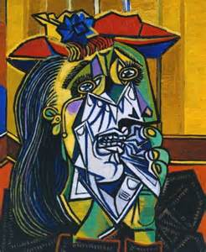

*This painting series is regarded as a thematic continuation of the tragedy depicted in Picasso’s epic painting Guernica. By focusing on the image of a woman crying, the artist was no longer painting the effects of the Spanish Civil War directly, but rather referring to a singular universal image of suffering*

**Task 1. Answer the following questions based on the painting**

1. What image is seen in the painting?
2. What is the expression of the image? Explain the details to support your answer.
3. Do you think the painting is an accurate representation of reality? Explain your answer.

DEPARTMENT OF EDUCATION

DIVISION OF BOHOL

**ENGLISH GRADE X LEARNING ACTIVITY SHEET Module 4 Lesson 2.3**

*Title* : Analyzing the Theme of a Poem

*Learning Targets*: Explain how the elements specific to a genre contribute to the theme of

a particular literary selection (poetry).

*Reference*: English 10 Learner’s Manual (Authors:) Almonte, Liza et. al. (pages:)427- 429

**Concept:**

This poem that we are to study seeks to describe human behaviour and objects as if they are being seen for the first time by a visiting Martian. Consequently, the tone is detached and objective, but also inquisitive. The ordinary and commonplace are illuminated by a fresh perspective in thirty-four unrhymed couplets. While the poem is almost like a series of riddles that invite the reader to decipher them, the use of language is original and evocative.

**A Martian Sends a Postcard Home**

*Craig Raine (1979)*

*Caxtons are mechanical birds with many wings*

*and some are treasured for their markings -*

*they cause the eyes to melt*

*or the body to shriek without pain.*

*I have never seen one fly, but*

*sometimes they perch on the hand.*

*Mist is when the sky is tired of flight*

*and rests its soft machine on ground.*

*then the world is dim and bookish*

*like engravings under tissue paper.*

*Rain is when the earth is television.*

*It has the property of making colours darker.*

*Model T is a room with the lock inside –*

*a key is turned to free the world*

*for movement, so quick there is a film*

*to watch for anything missed.*

*But time is tied to the wrist*

*or kept in a box, ticking with impatience.*

*In homes, a haunted apparatus sleeps,*

*that snores when you pick it up.*

*If the ghost cries, they carry it*

*to their lips and soothe it to sleep*

*with sounds. And yet, they wake up*

*deliberately, by ticking with a finger.*

*Only the young are allowed to suffer*

*openly. Adults go to a punishment room*

*With water but nothing to eat.*

*They lock the door and suffer the noises*

*alone. No one is exempt*

*and everyone’s pain has a different smell.*

*At night, when all the colours die,*

*they hide in pairs*

*and read about themselves –*

*in colour, with their eyelids shut.*

**Task 1. Answer the following based on your analysis of the poem.**

1.What is the first object that the Martian described? 3. How does the Martian describe the forms of weather?

2.What two forms of weather were mentioned in the poem? 4. What other objects were described?

DEPARTMENT OF EDUCATION

DIVISION OF BOHOL

**ENGLISH GRADE X LEARNING ACTIVITY SHEET Module 4 Lesson 2.4**

*Title* : Analyzing the Theme of a Movie

*Learning Targets*: Explain how the elements specific to a genre contribute to the theme of

a particular literary selection (movie).

*Reference*: English 10 Learner’s Manual (Authors:) Almonte, Liza et. al. (pages:)431- 432

**Concept:**

After analyzing a painting, a poem and several other literary genre, we will now focus our attention to a movie as another piece of literary work.

Both a classic movie for kids and a remarkable portrait of childhood, E.T. is a sci-fi adventure that captures that strange moment in youth when the world is a place of mysterious possibilities (some wonderful, some awful), and the universe seems somehow separate from the one inhabited by grown-ups. Henry Thomas plays Elliott, a young boy living with his single mother (Dee Wallace), his older brother Michael (Robert MacNaughton), and his younger sister Gertie (Drew Barrymore). Elliott often seems lonely and out of sorts, lost in his own world. One day, while looking for something in the back yard, he senses something mysterious in the woods watching him. And he's right: an alien spacecraft on a scientific mission mistakenly left behind an aging botanist who isn't sure how to get home. Eventually Elliott puts his fears aside and makes contact with the "little squashy guy," perhaps the least threatening alien invader ever to hit a movie screen. As Elliott tries to keep the alien under wraps and help him figure out a way to get home, he discovers that the creature can communicate with him telepathically. Soon they begin to learn from each other, and Elliott becomes braver and less threatened by life. E.T. rigs up a communication device from junk he finds around the house, but no one knows if he'll be rescued before a group of government scientists gets hold of him.

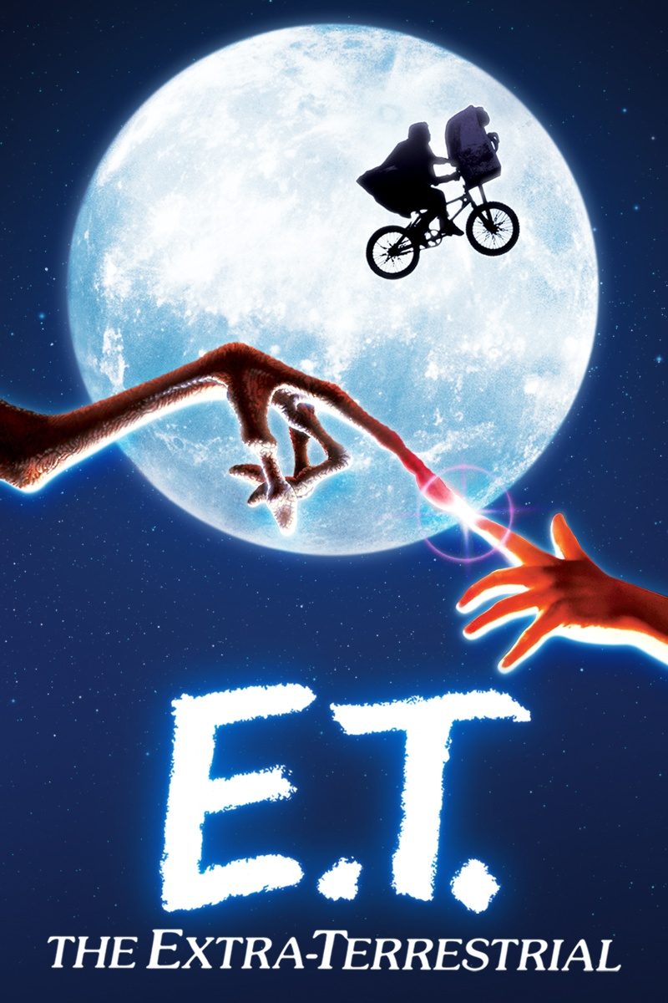

**Task 1. Answer the following based on your analysis of the movie.**

1. Choose **one word** to describe your reaction to the movie.
2. What image from the movie lingers in your mind?
3. How would you describe the film to someone who hasn’t seen it?
4. What do you think is the message of the film?
5. Who are the characters in the film? Describe their reaction in meeting and overcoming a problem.
6. What new ideas did you get from the film?
7. Has the film influenced your thinking in terms of bridging gaps? Explain your answer.

DEPARTMENT OF EDUCATION

DIVISION OF BOHOL

**ENGLISH GRADE X LEARNING ACTIVITY SHEET module 4 lesson 2.5**

*Title* : Bridging Gaps Through Cultural Mapping

*Learning Targets*: Familiarize and apply how cultural mapping is done as a research work

Influence others through cultural mapping

*Reference*: English 10 Learner’s Manual (Authors:) Almonte, Liza et. al. (pages:)434- 435

**Concept:**

Cultural mapping refers to a research tool to holistically understand the cultural assets of a place based on the local knowledge of the people. Cultural mapping is gaining more acceptance as an essential planning and economic development tool that helps planners rediscover the wealth of places.

**Task 1. In your groups, decide on a local heritage that you would like to preserve. Talk about its importance, its history, and its influence to your culture. You must also use the internet to gather relevant information about your chosen topic. Use the template to complete this activity. You will assign one or two representatives from your group to share your output in class. Remember: You must interview persons who are experts and knowledgeable on your chosen local heritage.**



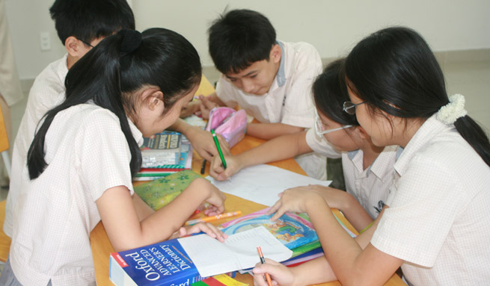

ENGLISH 10

FOURTH QUARTER

Lesson 3

Activity Sheet No. 1

ACTIVITY TITLE : Classifying Static and Dynamic Characters

LEARNING TARGET : Classify static and dynamic characters

REFERENCE : English 10 Learner’s Material, pp. 439-440.

A static character is one that does NOT undergo important change in the course of the story, remaining essentially the same at the end as he or she was at the beginning.

A dynamic character, in contrast, is one that does undergo an important change in the course of the story.

Task: STATIC OR DYNAMIC

Classify the following popular characters whether they are static or dynamic.

|  |  |  |
| --- | --- | --- |
| STATIC | CHARACTERS | DYNAMIC |
|  | Harry Potter |  |
|  | Eponine |  |
|  | Jean Valjean |  |
|  | Shrek |  |
|  | Elsa |  |
|  | Draco Malfoy |  |
|  | Aslan |  |
|  | Frodo |  |
|  | Fantine |  |

1. Based on your answers above, why do you say that the characters are static or dynamic?

ENGLISH 10

FOURTH QUARTER

Lesson 3

Activity Sheet No. 2

ACTIVITY TITLE: Evaluating the unity of plot, setting and characterization

to achieve the author’s purpose

LEARNING TARGET: Evaluate the unity of plot, setting and characterization

to achieve the author’s purpose.

REFERENCE: English 10 Learner’s Material, pp. 442-447.

Les Miserables employs Hugo’s style of imaginative realism, a very detailed and believable creation of an imagined world, and is set in an artificially created human hell that emphasizes the three major predicaments of the nineteenth century. Each of the three major characters in the novel symbolizes one of these predicaments: Jean Valjean represents the degradation of man in the proletariat, Fantine represents the subjection of women through hunger, and Cosette represents the atrophy of the child by darkness. In part, the novel’s fame has endured because Hugo successfully created characters that serve as symbols of larger problems without being flat devices.

Task: Read the excerpt of Les Miserables . Work with your group and complete

the task assigned to you.

Group I Identify the character’s emotions, thoughts and actions through a

comic strip.

Group II Draw the scene when the two characters meet.

Group III Retell the events using cohesive devices. Use a graphic organizer to

help you in retelling.

Group IV Act out the scene when Jean Valjean meets Cosette.

Group V Tell the purpose of the author in writing the story by filling up the table .

|  |  |  |
| --- | --- | --- |
| Author’s Purpose in Writing the Story | | |
| To persuade | To inform | To entertain |
| Details | Details | Details |

ENGLISH 10

FOURTH QUARTER

Lesson 3

Activity Sheet No. 3

ACTIVITY TITLE: Determining the Tone, Mood and Techniques of the Author

LEARNING TARGET: Determine the tone, mood and techniques of the author

REFERENCE: English 10 Learner’s Material, pp. 447-448.

TASK 1: ( Teacher will provide a copy of the movie Les Miserables and let the

students watch it )

The Movie, Les Miserables

TASK 2:

Answer the following questions accordingly:

1. What was the best part of the movie for you?
2. Who was your favorite character in the movie? Why?
3. What feelings did you share with any characters in the movie?
4. If you were the author, would you change the ending? What changes would you do?
5. If you were the Bishop, what would you do if you discovered what Valjean stole from you? Would you forgive him or would you let

MODULE 4

Lesson 4

Activity No. 4.1

Activity Title: Drawing Conclusions From The Set of Details

Learning Target: Draw conclusions from the set of details

|  |
| --- |
| Drawing conclusions ask one to evaluate details and make a judgement. Learning to draw conclusion is an important tool as it aids in comprehending text. |

ACTIVITY.

Fill out the matrix using the levels of proficiency matrix found on page 458 ( to be provided by the teacher). What is your level of proficiency in each subject? Then, answer the questions below.

|  |  |
| --- | --- |
| Subjects | Level of Proficiency |
| Math |  |
| English |  |
| Filipino |  |
| Social Studies |  |
| Science |  |
| MAPEH |  |
| Values |  |

Answer briefly:

1. In what subject areas are you doing well? How can you sustain this?
2. What areas need improvement?
3. What can you say about your overall performance in all your subject areas? How do you assess your overall performance in all your subject areas?

English 10

Module 4- Lesson 4

Activity Title: Noting Differences and Similarities of Liberal and Technical Education

Learning Target: Raise questions and seek clarification on issues discussed in the text

listened to or read

Reference: English 10 LM pp. 462-464

English 10 TG pp. 421-422

**Concept Notes**

The word “liberal”, which means “belonging to a free man”, comes from a world where slavery existed, and has survived into times when in the literal sense. Subjects like history, literature, languages, pure mathematics and sciences are liberal education, but subjects like bookkeeping, business administration, commercial French accountancy, cooking and shorthand are technical or vocational.

**Activity:**

Read the text **“What is a Liberal Education?”** Please refer to Learner’s Material pages 462-464.

Note. The teacher may provide photocopies of the text by group. After reading the story, the students should answer the questions that follow.

1. What does liberal education mean?
2. What constitute liberal education?
3. What is the origin of the word liberal?
4. What is the technical education? Is it important? Why?
5. What is the difference between technical and liberal education?

**Activity No. 4**

Activity Title: Knowing Some Research Terms

Learning Target: Get familiar with technical terms used in research

Reference: English 10 LM pp. 466-467

English 10 TG pp. 425

**Concept Notes**

As you get already to write your research report, review what you have done so far. Use the checklist below to determine if you are ready to write your draft knowing the technical terms used in research.

**Activity A: Make A Match!**

Get to know some research terms. Match the description in the Premises (A) with corresponding section names listed in column B. Write only the letter your answer before each number.

|  |  |
| --- | --- |
| **A** | **B** |
| _____ 1.presents background information, scope, and focus of the research paper | 1. Methodology |
| _____ 2. provides a review of what others have written or researched on concerning the topic | 1. Literature Review |
| _____ 3. explains how the research was conducted | 1. Introduction |
| _____ 4. presents the information gathered through the research | 1. Reference |
| _____ 5. evaluates the results of the study or research | 1. Discussion |
| _____ 6. provides the summary of the research | 1. Conclusion |
| _____ 7. lists all the sources used in the research | 1. Results |
| _____ 8. contains other related information such as graphs, charts, tables, lists | 1. Research |
| _____ 9. summarizes all sections and helps readers decide whether or not to read the entire report | 1. Abstract |
| _____ 10. a systematic investigation to contribute to an existing body of knowledge | 1. Appendix |

Module 4 Lesson 6

Activity No. 1

Activity Title: Advocating Global Citizenship

Learning Target: Describe the emotional appeal of a text

Reference: Celebrating Diversity Through World Literature, pp. 485-491

Thinking and feeling alone will not do much in addressing societal concerns and in making difference in our global society. UNESCO forwards that being a global citizen means acquiring the “knowledge, skills, values and attitudes learners need to build a more just, peaceful, tolerant, inclusive, secure and sustainable world.”

Activity:

1. Watch the Michael Jackson’s music video entitled, “Man in the Mirror” and reflect on the message of the song.
2. Read the short write-up about Severn Suzuki and her speech.
3. Answer the following questions:
4. What organization does Severn Suzuki belong to? What is the goal of her group?
5. What environmental phenomenon is Suzuki referring to in paragraph 4?
6. What are the four points that she posits concerning the inability of the adults to address the problems of the world?
7. What appeal does she make? What message does she want to emphasize?
8. What challenge does she pose at the end of her speech? What can you say about this?

Module 4 Lesson 6

Activity No. 2( To be taken for 2 days )

Activity Title: Think, Share, Act!

Learning Target: Compose a research report on a relevant social issue

Reference: Celebrating Diversity Through World Literature, pp.492-496

Day 1 Group Activity:

1. Through an infographic, UNESCO has outlined the issues that hinder the world from being truly connected. Find out by going over the details of the infographic excerpts.

Photo Source: <http://www.globaleducationfirst.org/4083.htm>

|  |  |  |
| --- | --- | --- |
| What are the global issues that UNESCO outlines in the infographic? | Which of these issues  struck you most? What  do you want to share  about this issue? | What specific steps can you take as a global citizen? |
|  |  |  |

Day 2

1. Through the research writing process, you have investigated on a social issue, discussed your findings, and proposed solutions and options to address the issue. You can extend your advocacy by presenting your case through a presentation. Consider the points below as you prepare for this endeavour:
2. Use the worksheet for your presentation.
3. Create a slide which forwards the road map of your presentation.
4. Summarize segments of your research into phrases or short sentences.
5. Use graphs, illustrations, or tables, among others, in presenting and discussing the results of your research.

Module 4 Lesson 6

Activity No. 3

Activity Title: Delivering a Self-Composed Campaign Speech on Advocacies, Social Issues and Concerns

Learning Target: Deliver a self-composed campaign speech on advocacies, social issues and concerns

Reference: Celebrating Diversity Through World Literature, pp. 497-498

In line with their centennial celebration, the United World is sponsoring a gathering, tagged as “Rebuilding Our Societies,” for young global leaders. The convention is a venue for young leaders to present options and solutions to pressing social concerns and issues. Your group has been selected to present the research that you have conducted.

Goal: Offer options and solutions to pressing social concerns and issues.

Role: Researchers and presenters

Audience: Young Global leaders

Situation: United World’s Centennial Celebration

Product: Research Report with accompanying presentation slides

Standards:

1. Research Report:
2. Catchy introduction
3. Credible
4. Well-explained
5. Well-organized
6. Compelling conclusion
7. Well-written
8. Oral Presentation
9. Preparedness
10. Visual support

Effective verbal and non-verbal strategie